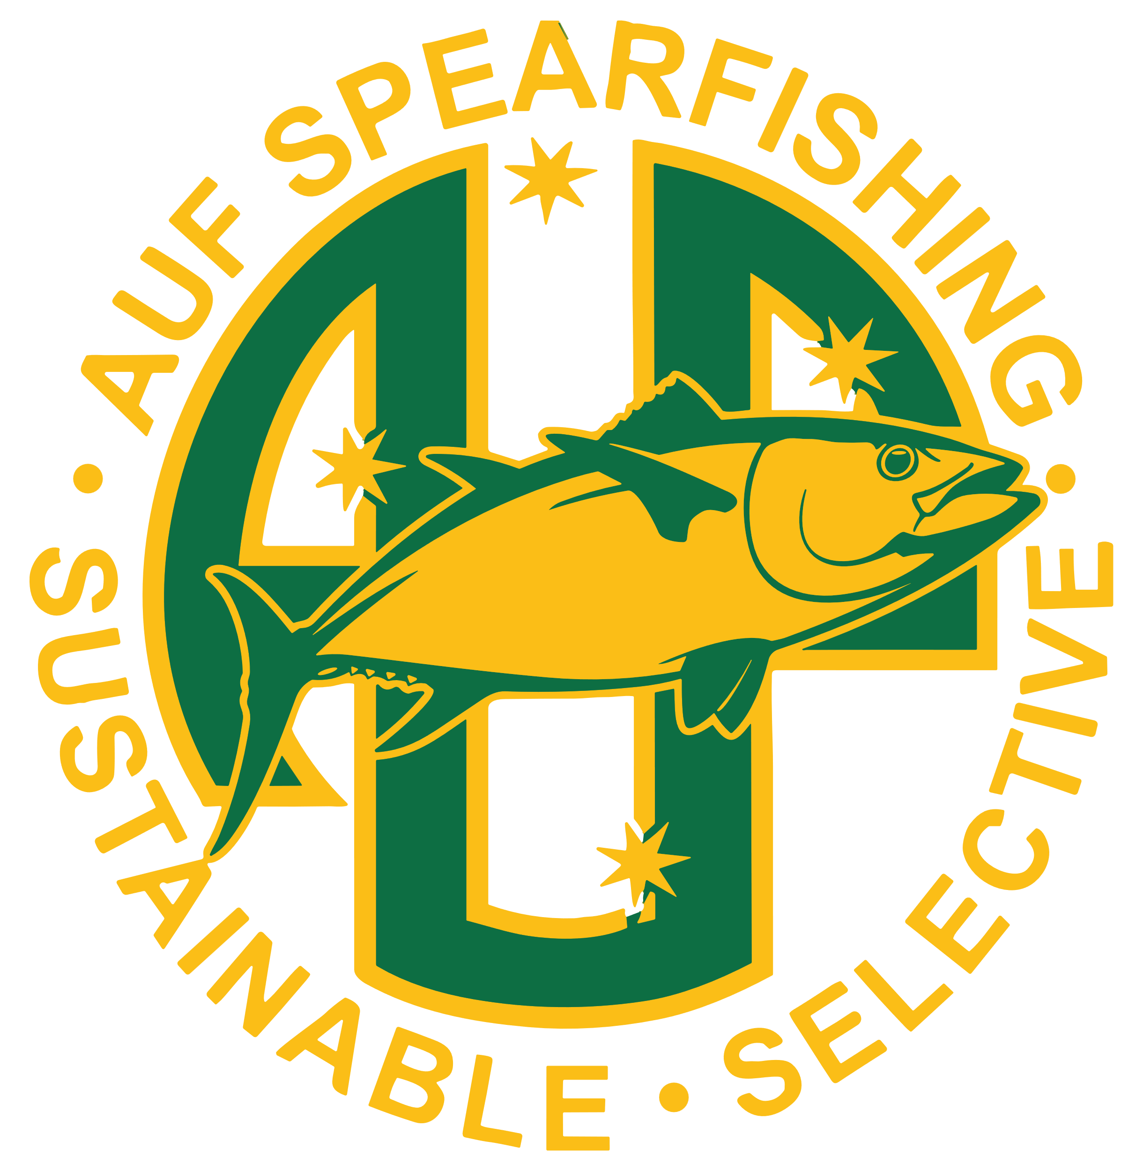 |  |  | Australian Underwater  Federation Inc.  APPLICATION FOR NATIONAL AND/OR STATE SPEARFISHING RECORD  (PRINT IN BLOCK LETTERS)
This form must be accompanied by CLEAR PHOTOGRAPHS showing length and girth of species. It is preferred an object for scale or a tape measure is shown in the photo. Refer to guide for additional invertebrate requirements.
SPECIES (Scientific Name) |  |  |  | Click or tap here to enter text.
(Common Name) |  |  |  | Click or tap here to enter text.
Reference or Identification Source |  |  |  | Click or tap here to enter text.
Select Invertebrate type from drop down menu
Weight  (kg) |  | Click or tap here to enter text. |  | Length  (cm) |  | Click or tap here to enter text. |  | Max.Girth (cm) |  |  | Click or tap here to enter text. |  | Invertebrate  Measurement |  | Select invertebrate type above for info.
Date of Capture |  | Click or tap here to enter text. |  | Place of Capture |  | Click or tap here to enter text. |  |  |  |  | State of Capture |  | Click or tap here to enter text.
Category of Application: |  |  |  | ☐ National |  |  |  | ☐ State |  |  |  |  | ☐ Club
 |  |  |  | ☐ Open |  |  |  | ☐ Women's |  |  |  |  | ☐ Junior (under 18)
Full Name of Applicant |  |  |  | Click or tap here to enter text.
Postal address |  |  |  | Click or tap here to enter text.
 |  |  |  | Click or tap here to enter text. |  |  |  |  |  |  |  | Post Code |  | Click or tap here to enter text.
Phone No |  |  |  | Click or tap here to enter text. |  |  |  |  | Email address |  |  | Click or tap here to enter text.
Affiliated Club |  |  |  | Click or tap here to enter text. |  |  |  |  | State Branch |  |  | Click or tap here to enter text.
Registered AUF Membership No |  |  |  | Click or tap here to enter text.
Type of Equipment Used  (handspear or speargun) |  |  |  | Click or tap here to enter text.
AFFIDAVIT
We, the undersigned, declare that the above named fish was landed without assistance and that the above information and statements are true. This fish was taken by the diver in accordance within the rules of the AUF.
SIGNATURE OF DIVER  X________________________________________ |  |  |  |  |  |  | Witness to catch  X________________________________________
Name | Click or tap here to enter text. |  |  |  |  |  | Name |  |  | Click or tap here to enter text.
 |  |  |  |  |  |  | Address |  |  | Click or tap here to enter text.
 |  |  |  |  |  |  | Phone No |  |  | Click or tap here to enter text.
AFFIDAVIT
We, the undersigned, do hereby declare that the abovenamed fish was weighed in our presence and that the weight is correct as stated.
Weigh master  X________________________________________ |  |  |  |  |  |  | Independent Witness to weighing  X________________________________________
Name | Click or tap here to enter text. |  |  |  |  |  | Name |  |  | Click or tap here to enter text.
Address | Click or tap here to enter text. |  |  |  |  |  | Address |  |  | Click or tap here to enter text.
Phone No | Click or tap here to enter text. |  |  |  |  |  | Phone No |  |  | Click or tap here to enter text.
Type of Scales Used - provide all details: Brand, model, certification, calibration certificate. Photos preferred where possible:
 | Click or tap here to enter text.
TRANSFER $10 APPLICATION FEE TO:
AUF RECORDS BSB: 923 100 ACCOUNT: 46308411 REFERENCE: APPLICANT’S NAME
BANK TRANSFER RECIEPT NUMBER: |  |  |  |  | Click or tap here to enter text.
SEND APPLICATION AND ALL PHOTOS/ADDITIONAL INFORMATION TO aufrecords@yahoo.com
FOR ANY FURTHER INFORMATION CONTACT VIN RUSHWORTH: 0407 122067
Version. August 2023

