68th AUSTRALIAN SPEARFISHING CHAMPIONSHIPS
(Inaugural Pairs Only Event)
TOWN OF 1770 - QUEENSLAND | 30 JULY 22 – 4 AUG 22
in conjunction with the
QUEENSLAND SPEARFISHING TITLES

INFORMATION PACK & “B-SECTION RULES”

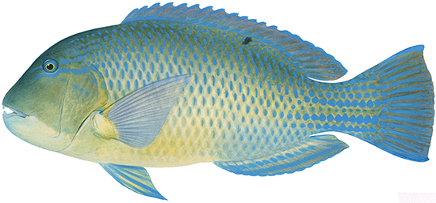

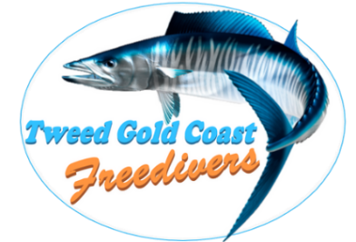 |  | 

Contents
The Venue 3
Registration and Fees 3
Pairs Format 3
General Information 4
Organising Committee 4
Competition Committee 4
Competition Safety boats 4
Accommodation 6
Possible Dive Sites 6
Queensland Spearfishing Titles 6
Score Sheet and System 6
Titles and Trophies 6
Penalties 6
Titles and Trophies: 68th Australian Spearfishing Championships 7
Titles & Trophies: Queensland Spearfishing Titles 8
Official Spearfishing Scoresheet 9
Official Film-Fishing Scoresheet 11
Guidelines for True-Pairs 12
Safety Notice to Competitors 13
Town of 1770 Location Map 15
Boat Ramp Location 15
Bunker Group Reefs 16
Fitzroy Reef 17
Lamont Reef 17
Boult Reef 18
Musgrave Island 18
Bustard Head & Jansen Rock 19
Rock Cod Shoals 19
Tide Times 20
Prevailing Winds 21
Online Resources 21
Competition Risk Assessment & Action Plan 22
Medical and Emergency Contact List 25

The Venue

The Australian Underwater Federation, AUFQ, Tweed Gold Coast Freedivers and Sunny Coast Skindivers would like to invite all interested divers to compete in the 68th Australian Spearfishing Championships to be held in the Town of 1770, Queensland in 2022.
The Town of 1770 is situated on a peninsula, with the Coral Sea and Bustard Bay on three sides and can be reached by a sealed road from Bundaberg, 120 kilometres to the south, going through Agnes Water (immediately to the south). The town sustains a small permanent population; a significant holiday population makes it to the area to take advantage of fishing, Great Barrier Reef trips and other water activities. The town is built on the site of the second landing in Australia by James Cook and the crew of HM Bark Endeavour in May 1770 (and their first landing in what is now the State of Queensland).
The village is a tourist destination on Queensland's Discovery Coast. The village itself contains holiday accommodation, restaurants, general store, hotel, picnic areas with free barbecues and a small marina where daily trips depart for Lady Musgrave Island on the Great Barrier Reef, and several trips a week to Bustard Head Light Station.

Call for Boats

Please note: Be prepared to organise your own boat transport for duration of the competition.
The Tweed Gold Coast Freedivers and Sunny Coast Skindivers have limited boats within the club to conduct the event. As such, if you have a boat available please let us know as soon as possible to assist with planning. We’re looking at a bit of a subsidy to help long distance towing from interstate.
Warning: Offshore capable medium to larger boats will be necessary due to distances needed to travel to some locations (in excess of 30 nautical miles). There can be severe chop at times.

Registration and Fees

We will be trying to keep registration fees to an absolute minimum. Generally, competitors are to sort out fuel / travel costs with their respective boat owners. Sausage sizzle and soft drinks will be available at weigh-in. Registration and Presentation dinners will be at competitor’s own expense.

National titles only: | $250.00
National Titles and Queensland Titles: | $255.00

Online registration is available at: https://australianspearfishingchampionships.com.au

To facilitate organization of the event, in particular t-shirts and boat places, there will be an early cut-off for registrations of 18 June 2022. Please note, that while the organisers will make all reasonable attempts to provide competitors without boat places a spot this cannot be guaranteed.

Pairs Format

This year, in keeping with the AUFs motto of ‘SAFE SUSTAINABLE SELECTIVE SPEARFISHING’ the National Titles will for the first-time shift from an individual format to a True-Pairs format with scoring based on one species per True-Pair per day. The change aligns with current ‘best practice’ pairs competitions being held in places like Queensland, Western Australia and New Zealand, along with the Inter-Pacific.
Scoring will be based on one species per True-Pair per day of competition. You will see from the scoresheet there is a wide variety of eligible species available to competitors.

General Information

The ocean conditions in 1770 will “dictate the terms” as far as where and when we dive. The agenda of events is a guideline only and there will need to be some flexibility. Priority will be given to the Open Spearfishing Championship, followed by Film-Fishing / Fin-Swimming. The Open Spearfishing Championship will be conducted from boats over 3 days (Heats 1 to 3). For Sub-Juniors, Fin-Swiming and Film-Fishing please see the Agenda below. All competitors must be financial members of the Australian Underwater Federation. Overseas CMAS recognised countries competitors are also welcome and should register without delay.

NOTE: Fisheries Officers are red hot around this region. Make sure you are aware of the strict rules relating to all aspects of fishing.

Given the competition will be held in the Great Barrier Reef Marine Park, competitors should be aware the various combined Queensland Fisheries possession limits:

CORAL REEF FIN FISH (see blue section of the scoresheet) - Combined possession limit of 20 in total
CODS AND GROUPERS - Combined possession limit of 5 in total
CORAL TROUT - Combined possession limit of 7 in total
WRASSE - Combined possession limit of 6 tuskfish*

Other size and possession limits apply – see https://www.qld.gov.au/recreation/activities/boating-fishing/rec-fishing/rules/limits-tidal

Organising Committee

Luke Randell (Tweed Gold Coast Freedivers) | 0411 468 523 | associateservices1@gmail.com
Geoff Gannon | 0433 444 400 geoffreygannon@hotmail.com
Jenni Budworth | tweedgoldcoastfreedivers@hotmail.com
Adrian Wayne (AUF National Chair) | 0418 282 696 | adrian.wayne48@gmail.com
Michael Pannach (AUFQ State Chair) | 0408 254 564 | michael.pannach@cosu.com.au

Competition Committee

Championship Director | Gary Drew
Sign On / Off Clerk and Timekeeper | Jenni Budworth
Weighmaster | Mick McDade
Scorekeeper | Luke Randell

Competition Safety boats

Primary Safety Boat: Garry Drew – Eden Craft
Secondary Safety Boat: Spencer Robinson – Yamaha Southwind Longboat (Mr Wong)

Schedule of Events

PRELIMINARY AGENDA OF EVENTS
Please note that events or locations may change due to weather and/or other unforeseen events. The location of each day’s event will be advised by 6:00pm the day prior.

DAY | EVENT | ADDITIONAL INFORMATION
Saturday  30 July 2022 | Registration and Briefing  Meet other competitors and buy your own counter meal / drinks  From 5:00 pm  6 pm Team managers meeting | Location:  To be advised
Day 2  Sunday  31 July 2022 | Spearfishing Heat 1:  Australian Spearfishing Championships  Queensland Spearfishing Titles | Each day competitors to meet at the boat ramp at 5:30am for briefing and gear safety inspection.  Depart for reef by 6:00am  Competition 8:00am – 1:00pm  Depart reef 1:30pm  Weigh-in commence 4:00pm  Address to be advised
Day 3  Monday  1 August 2022 | Spearfishing Heat 2:  Australian Spearfishing Championships  Queensland Spearfishing Titles & Nemrod Cup | As above for Day 2.
Day 4  Tuesday  2 August 2022 | Film fishing & swim race  Sub-juniors if required  Times to be notified. | This day may be changed if the  weather has been unfavorable or  the forecast isn’t suitable.
Day 5  Wednesday  3 August 2022 | Spearfishing Heat 3:  Australian Spearfishing Championships | As above for Day 2.
Day 6  Thursday  4 August 2022 | Presentation 1:00pm  Spare day to be used in inclement weather only, Presentation will change to 6pm | Location:  To be advised

Accommodation

Competitors will be responsible for arranging their own accommodation and it is highly recommended to book accommodation ASAP to secure a booking.
There is an array of accommodation such as caravan parks, motels and holiday house rentals. By way of example, please refer to Airbnb and Stayz for what is available:
https://www.stayz.com.au/search/keywords:seventeen-seventy-queensland-australia
https://www.airbnb.com.au/seventeen-seventy-australia/stays

Possible Dive Sites

Preferred locations: Fitzroy Reef | Lamont Reef | Boult Reef | Lady Musgrave Island
Reserved for adverse conditions: Bustard Head & Jansen Rock | Rock Cod Shoals

Queensland Spearfishing Titles

The Queensland Spearfishing Titles is only open to AUFQ Club Members.
The Queensland Spearfishing Titles will be held in conjunction with the Australian Spearfishing Championships
over the first two days of competition. The Nemrod Cup will be held on the second day of competition.

Score Sheet and System

The standard Australian Underwater Federation scoring system will be used, namely 100 points per species, 10 points per kilogram of weight; and max weight of any one fish of 15 kg. Each True-Pair can weigh-in one species listed on the score sheet per day.
No unlisted species will be eligible; only those on the score sheet are eligible (see Official Spearfishing Scoresheet attached).
Any competitor, pair or team who infringes fisheries or marine park limits or regulations will be disqualified from all competitions. All fish shall remain the property and responsibility of the competitor.

Titles and Trophies

Commencing in 2022 the Australian National Spearfishing Titles shall be swum as True-Pairs with Titles and Trophies being awarded to categories within True-Pairs Competitions, Nominated Pairs Competitions and Individual Competitions.

Penalties

A 100 point penalty will apply in each instance any competitor’s fish presented for weighing is: an ineligible species; one under minimum comp weight; or in excess of the allowable number for that species. Any competitor, pair or team who infringes fisheries or marine park limits or regulations will be disqualified from all competitions.
Competitors who have not reached the designated finish point by the conclusion of the competition will be disqualified from that day’s competition.

Titles and Trophies: 68th Australian Spearfishing Championships
True-Pairs categories are as follows:
CATEGORY | REQUIREMENTS
Australian Champions  Open Spearfishing Championship | Any gender / Any State combination  Gold / Silver / Bronze medals awarded to top three True-Pairs.
Mixed Pairs | A True-Pair consisting of a male and female / All ages / Any State combination
Neptune’s Apprentice | A True-Pair consisting of an adult and Junior / Any gender / Any State combination
State Team Championship | Team Event | Top 3 same State pairs  All ages / Any gender / Same State combination  Nomination not required
Top Team Championship | Team Event | Top 2 Pairs  All ages / Any gender / Any State combination  Nomination Required
Most Species | 'Most Species' title is awarded to the True-Pair with the most species caught across all Spearfishing Championships.  In the case where more than one fish per species is weighed-in, then those fish shall count as only one for the purposes of this award.
In Nominated Pairs Competitions the pair does not have to swim together (such as in True-Pairs); rather any two competitors in a particular category (ie age / gender) can nominate prior to the commencement of the Open Spearfishing Championship. Nominated Pairs categories are as follows:
CATEGORY | REQUIREMENTS
Grand Master | For competitors aged 64 years and over
Master | For competitors aged 55 to 63 years
Veteran | For competitors aged 45 to 54 years old
Senior | For competitors aged 25-44
Intermediate | For competitors aged 18-24
Junior | For competitors aged 15-17
Women’s | For female competitors aged 15 and over
As regards the scoring of Junior and Women’s Nominated Pairs Competitions: competitors are allowed their own individual fish tally and each Competitor’s individual scores are then added together. As regards all other Nominated Pairs categories 50% of each competitor’s True-Pair score will be combined for their Nominated Pairs score.
In Individual Competitions (except the Fin Swimming), the competitors must swim in a pair or be accompanied by a safety observer. Individual Competition categories are as follows:
CATEGORY | REQUIREMENTS
Sub-Junior  Spearfishing Championship | Individual Competition swum with an observer | For competitors aged under 15 years  Scores taken from the Sub-Junior Spearfishing Championship
Fin-Swimming | Individual Competition
Film-Fishing | Individual Competition (swum in pairs)
Super-Diver | Individual Competition
Most Meritorious Fish | Individual Competition | As judged by the Championship Director from fish taken during either the Open or Sub-Junior Spearfishing Championships
Largest Fish | Heaviest fish weighed in during the competition.

Titles & Trophies: Queensland Spearfishing Titles

The Queensland Spearfishing Titles are only open to financial members of AUFQ clubs.

The Queensland Spearfishing Titles shall be contested in the True-Pair format with the following competition categories during the first two days of the 68th Australian Spearfishing Championships:

CATEGORY | REQUIREMENT | TROPHIES
SPEARFISHING | Open category | Cilento Championship
CHAMPIONSHIP OF QLD | Any age, sex, club combination | shield & runner-up
 |  | trophy
VETERAN SPEARFISHING | 45 years or older pair  Any sex, club combination | Veterans’ shield
CHAMPIONSHIP OF QLD | 45 years or older pair  Any sex, club combination | Veterans’ shield
LADIES SPEARFISHING | All female pair  Any age, club combination | Ladies’ shield
CHAMPIONSHIP OF QLD* | All female pair  Any age, club combination | Ladies’ shield
JUNIOR SPEARFISHING | 15-17 years of age pair  Any sex, club combination | Monty Young
CHAMPIONSHIP OF QLD* | 15-17 years of age pair  Any sex, club combination | Memorial Shield
SUB-JUNIOR | <15 paired with an adult # | Aimrite Shield
CHAMPIONSHIP OF QLD  (adult/child)# | <15 paired with an adult # | Aimrite Shield
CLUB PAIRS | Same club pairs (rules 64 & 65)  Nomination required  Any age, sex combination | Pairs trophy
CHAMPIONSHIP OF QLD |  | Pairs trophy
CLUB TEAMS | 2 x same club pairs  Nomination required  Any age, sex combination | The Dolphin Club of  Townsville shield
CHAMPIONSHIP OF QLD |  | The Dolphin Club of  Townsville shield
NEMROD CUP | Top 2 same club pairs  Nomination not required  Any age, sex combination | Nemrod Cup

* It was agreed at the AUFQ Spearfishing Commission meeting held on 19 March 2022 that this year the Junior Spearfishing Championship of Qld and the Ladies Spearfishing Championship of Qld will be trialled on a ‘Nominated Pairs’ basis in alignment with the new national “A Section Rules”.

# This year the Sub-Junior Championship of Qld will be run in conjunction with the Australian Spearfishing Championships Sub-Junior Spearfishing Championship in accordance with the new national “A Section Rules” [Individual Competition swum with an adult observer | For competitors aged under 15 years]

Official Spearfishing Scoresheet
Scoresheet Notes: Only those species shown on this scoresheet are eligible.
No unlisted fish. Only one of each listed species to be weighed-in per True-Pair per day.
All fish weighed-in must be a MINIMUM of 1kg – this applies to all eligible species. Lengths in round brackets refers to minimum legal size.
PARROT FISH - All parrot species must be gutted prior to weigh in. Maximum of any 3 listed parrot species per True-Pair per day.
MARLIN – only one marlin species allowed per True-Pair per day

Please note – Competitors should be aware of the Queensland Fisheries combined possession limits:
CORAL REEF FIN FISH (blue section of the scoresheet) - Combined possession limit of 20 in total
CODS AND GROUPERS - Combined possession limit of 5 in total
CORAL TROUT - Combined possession limit of 7 in total
WRASSE - Combined possession limit of 6 tuskfish*
Other size and possession limits apply – see https://www.qld.gov.au/recreation/activities/boating-fishing/rec-fishing/rules/limits-tidal

CORAL REEF FIN FISH: combined possession limit of 20 in total
Cods and Groupers Combined possession limit of 5 in total
Maori Cod (45cm) | Epinephelus undulatostriatus
Oscillated Cod / White Spotted Grouper (38cm) | Epinephelus coeruleopunctatus
Purple Cod (38cm) | Epinephelus cyanopodus
Highfin Grouper (38cm) | Epinephelus maculatus
Coral Grouper (38cm) | Epinephelus corallicola
Tomato Cod (38cm) | Cephalopholis sonnerati
Peacock Rockcod (38cm) | Cephalopholis argus
Coral Rockcod (38cm) | Cephalopholis miniata
Freckled / Sixband Rockcod (38cm) | Cephalopholis sexmaculata
Redmouth Rockcod (38 cm) | Aethaloperca rogaa
Coral Trout Combined possession limit of 7 in total
Bar Cheek / Coastal Trout (38cm) | Plectropomus maculatus
Blue Spot / Footballer Trout (50cm-80cm) | Plectropomus laevis
Common / Leopard Trout (38cm) | Plectropomus leopardus
Passionfruit Trout (38cm) | Plectropomus areolatus
Coronation Trout (yellowedge) (38cm) | Variola louti
Emperors
Bigeye Seabream (25cm) | Monotaxis grandoculis
Longnose Emperor (38cm) | Lethrinus olivaceus
Redthroat Emperor (38cm) | Lethrinus miniatus
Spangled Emperor (45cm) | Lethrinus nebulosus
Yellowlip Emperor (25cm) | Lethrinus xanthochilus
Blue Spotted Sea Bream (25cm) | Gymnocranius microdon
Blacknape Large-Eye Sea Bream (25cm) | Gymnocranius satoi
Maori Sea Bream (25cm) | Gymnocranius grandoculis
Parrot Fish All parrot species must be gutted prior to weigh in. Maximum of any 3 listed parrot species per True-Pair per day.
Bicolour / Spotted Parrot (25cm) | Cetoscarus ocellatus
Blue Barred Orange Parrot (25cm) | Scarus ghobban
Green Tailed Parrot (25cm) | Scarus frenatus
Long Nosed Parrot (25cm) | Hipposcarus longiceps
Meadow / Ember / Half & Half Parrot (25cm) | Scarus rubroviolaceus
Spike Fin Parrot (25cm) | Scarus altipinnis
Steep / Blunt Head Parrot (25cm) | Chlorurus microrhinos
Tropical Snapper and Sea Perch
Darktail Snapper / Orange-Spotted Sea Perch (25cm) | Lutjanus lemniscatus
Red Hussar (25cm) | Lutjanus adetii
Large Mouth Nannygai / Saddletail Snapper (40cm) | Lutjanus malabaricus
Maori Sea Perch (25cm) | Lutjanus rivulatus
Moses Perch (25cm) | Lutjanus russelli
One Spot Sea Perch (25cm) | Lutjanus monostigma
Red Emperor (55cm) | Lutjanus sebae
Small Mouth Nannygai / Crimson Snapper (40cm) | Lutjanus erythropterus
Stripey Snapper (25cm) | Lutjanus carponotatus
Black-and-White Sea Perch (25cm) | Macolor niger
Midnight Sea Perch (25cm) | Macolor macularis
Blue Lined Sea Bream / Sailfin Snapper (25cm) | Symphorichthys spilurus
Green Jobfish (38 cm) | Aprion virescens
Smalltooth Jobfish (38cm) | Aphareus furca

Wrasse Combined possession limit of 6 tuskfish* in total
Black Spot Tusk Fish (30cm)* | Choerodon schoenleinii
Blue Tusk Fish (30cm)* | Choerodon cyanodus
Venus Tusk Fish (30cm)* | Choerodon venustus
Gold Spot Hog Fish [1kg min.] | Bodianus perdition
OTHER TIDAL SPECIES:
Other Fin Fish:
Barramundi (58cm-120cm) | Lates calcarifer
Barred Javelin (45cm) | Pomadasys kaakan
Silver Javelin (30cm) | Pomadasys argenteus
Dusky Flathead (40cm-75cm) | Platycephalus fuscus
Flathead – other (30cm) | Platycephalus spp.
Fingermark / Golden Snapper (35cm) | Lutjanus johnii
Mangrove Jack (35cm) | Lutjanus argentimaculatus
Grass Emperor (25cm) | Lethrinus laticaudis
Dash-and-dot Goatfish [1kg min.] | Parupeneus barberinus
Other wrasse:
Black Wrasse [1kg min.] | Coris aygula
Graphic Tusk Fish [1kg min.] | Choerodon graphicus
Thicklip Wrasse [1kg min.] | Hemigymnus melapterus
Mackerel & Tuna:
Grey Mackerel (60cm) | Scomberomorus semifasciatus
School Mackerel (50cm) | Scomberomorus queenslandicus
Spanish Mackerel (75cm) | Scomberomorus commerson
Spotted Mackerel (60cm) | Scomberomorus munroi
Longtail Tuna. [1kg min.] | Thunnus tonggol
Yellowfin Tuna. [1kg min.] | Thunnus albacares
Dogtooth Tuna [1kg min.] | Gymnosarda unicolor
Wahoo (75cm) | Acanthocybium solandri
Trevally
Blue Finned Trevally [1kg min.] | Caranx melampygus
Cale Cale / Longraker Trevally [1kg min.] | Ulua mentalis
Diamond Trevally [1kg min.] | Alectis indica
Pennant Fish [1kg min.] | Alectis ciliaris
Giant Oystercracker [1kg min.] | Trachinotus anak
Snub Nosed Dart [1kg min.] | Trachinotus blochii
Giant Queenfish (50cm) | Scomberoides commersonnianus
Golden Trevally [1kg min.] | Gnathanodon speciosus
Greater Amberjack (50cm) | Seriola dumerili
Highfin Amberjack (50cm) | Seriola rivoliana
Yellowtail Kingfish (60cm) | Seriola lalandi
Other Pelagic: * only one marlin species per True-Pair per day allowed
Cobia (75cm) | Rachycentron canadum
Mahi Mahi / Dolphin Fish (50cm) | Coryphaena spp.
Rainbow Runner [1kg min.] | Elagatis bipinnulata
Black Marlin [1kg min.]* | Istiompax indica
Indo-Pacific Blue Marlin [1kg min.]* | Makaira mazara
Striped Marlin [1kg min.]* | Kajikia audax
Indo-Pacific Sailfish [1kg min.]* | Istiophorus platypterus
INELIGIBLE SPECIES INCLUDE: All protected & unlisted species, including but not limited to: sharks, rays and crustaceans; all molluscs and shellfish; squids, octopus, cuttlefish; pipefish, flutefish and trumpetfish; marine mammals; all toad fishes; protected species; catfish and frogfish; and any other fish ineligible under “B Section Rules” as follows:
ALL PROTECTED SPECIES | GOLD SPOTTED COD
ALL UNLISTED SPECIES | BLACK SPOTTED COD
ALL SURGEONS | FLOWERY COD
ALL UNICORNS | CAMOUFLAGE COD
ALL BATFISH | GIANT TREVALLY
ALL PAINTED SWEETLIP | SUCKERFISH
ALL BARRACUDA | MILKFISH
ALL SPINEFOOT | MULLET
ALL DRUMMER
ALL UNLISTED COD AND GROUPER | PARROT – NAPOLEON
ALL UNLISTED GOATFISH | PARROT - SURF
ALL UNLISTED PARROT | PARROT – DARK QUARTER

Official Film-Fishing Scoresheet

SPECIES | PTS
Cods and Groupers
Maori Cod | 5
Oscillated Cod / White Spotted Grouper | 4
Purple Cod | 3
Highfin Grouper | 3
Coral Grouper | 5
Tomato Cod | 5
Peacock Rockcod | 2
Coral Rockcod | 3
Freckled / Sixband Rockcod | 3
Redmouth Rockcod | 5
Coral Trout
Bar Cheek / Coastal Trout | 2
Footballer Trout (yellow phase) | 4
Blue Spot Trout | 3
Common / Leopard Trout | 1
Passionfruit Trout | 5
Coronation Trout (yellow edge) | 4
Emperors
Bigeye Seabream | 2
Longnose Emperor | 5
Redthroat Emperor | 2
Emperor (Lethrinus spp.) | 1
Yellowlip Emperor | 5
Sea Bream (Gymnocranius spp.) | 1
Parrot Fish
Bicolour / Spotted Parrot  (red phase) | 3
Bicolour / Spotted Parrot  (green phase) | 5
Blue Barred Orange Parrot | 3
Green Tailed Parrot | 1
Long Nosed Parrot | 2
Meadow / Ember / Half & Half Parrot | 4
Spike Fin Parrot | 2
Steep / Blunt Head Parrot | 3
Tropical Snapper and Sea Perch
Darktail Snapper / Orange-Spotted Sea Perch | 3
Red Hussar | 1
Large Mouth Nannygai / Saddletail Snapper | 3
Maori Sea Perch | 3
Moses Perch | 1
One Spot Sea Perch | 4
Red Emperor | 4
Small Mouth Nannygai / Crimson Snapper | 3
Stripey Snapper | 1
Black-and-White Sea Perch | 4
Midnight Sea Perch | 4
Blue Lined Sea Bream / Sailfin Snapper | 5
Jobfish (spp.) | 2
Wrasse
Black Spot Tusk Fish | 3
Blue Tusk Fish | 3
Venus Tusk Fish | 1
Gold Spot Hog Fish | 4
OTHER TIDAL SPECIES:
Other Fin Fish:
Barramundi | 5
Javelin Fish (Pomadasys spp.) | 2
Flathead (Platycephalus spp.) | 3
Fingermark / Golden Snapper | 3
Mangrove Jack | 3
Dash-and-dot Goatfish | 3
Other wrasse:
Black Wrasse | 4
Graphic Tusk Fish | 1
Thicklip Wrasse (Hemigymnus spp.) | 1
Mackerel & Tuna:
Grey Mackerel | 3
Spanish Mackerel | 3
Dogtooth Tuna | 4
Wahoo | 5
Trevally
Blue Finned Trevally | 4
Cale Cale / Longraker Trevally | 3
Diamond Trevally | 4
Pennant Fish | 4
Giant Oystercracker | Snub Nosed Dart | 4
Giant Queenfish (50cm) | 3
Golden Trevally | 3
Amberjack | Kingfish (Seriola spp.) | 4
Other Pelagic:
Cobia | 4
Mahi Mahi / Dolphin Fish | 5
Rainbow Runner | 3
Marlin species | 5

Guidelines for True-Pairs
- AUF True-Pairs events closely follow the rules set down for the Interpacific events.
- True-Pairs are to use the same safety equipment as previously for and individual event (Compliant Float | Whistle and signaling mirror | Orange plastic safety sheet | Sheathed diver’s knife | Weight belt fitted with quick release buckle | cover to spear points | see the “A-Section Rules”).
- Two divers of similar capability team up and nominate to compete together as a True-Pair.
- The divers may have one gun each and spare guns unloaded and stored horizontally on a Compliant Float.
- Both divers must practice ‘one up-one down’. This means:
  - watching your buddy dive down, and return safely to the surface;
  - make eye contact after a dive - a blackout can occur up to 15 seconds after ascent; and
  - if you are diving with someone not as adept as you are, stay within their comfortable limits, not yours.
- The True-Pair tows one Compliant Float with the following set up:
    - two rig-lines are attached to the float; one is 4 metres long and the other is a maximum of 30 metres long;
    - Either rig-line may be bungee or part bungee;
    - One diver attaches the long line to his gun or person and is allowed to dive and spearfish;
    - The other diver holds onto the short line, remains on the surface and tows the float;
    - Divers alternate between the short and long rig lines between dives;
    - Both divers must always remain within 30 metres of the float whilst on the surface.
- Whilst the spearing diver is submerged the surface diver must always do his best to stay above the submerged diver and be aware of their position at all times.
- Both divers are not allowed to be submerged below the surface at the same time. Penalty is disqualification.
- The two divers can swap duties of spearing or towing to suit themselves.
- The diver on the surface must not dive, let go of the rig-line or endanger the submerged diver in any way.
- It’s not mandatory, but recommended, that the Compliant Float also be equipped with a coiled 50mtr light line and small drop weight in case the surface diver feels the need to immediately search and possibly dive to locate the submerged diver. If deployed, it would anchor the float in the proximity of the potential search area as a reference point.
- The True-Pair are only allowed to weigh-in one of each specie on the scoresheet per day of competition. Exceptions apply for Women’s and Junior Nominated Pairs.
- It’s also recommended that the pair work in depths and conditions where, either one could rescue the other in an emergency situation.
- These guidelines also apply when training / scouting for an event. Scuba, Hooker or similar may not be used when scouting.
- Dive well within your limits. Don’t push yourself. Never risk your life or that of another for the sake of a fish.

Safety Notice to Competitors
In the interest of a safe and incident free competition we all need to take responsibility. The organisers have taken reasonable measures to ensure this is possible.
Please ensure you fulfill your responsibility to take care of your own and fellow competitors’ safety.
Here is relevant information on safety during the event and some tips to help each competitor remember their role in helping make this happen.
- Each safety boat has a first aid kit with the operator on board. The Primary Safety Boat will be equipped with defibrillator and oxygen resus.
- Each safety boat is equipped with communication to the other safety boat, as well as shore base, and emergency services.
- A competitor may only approach, touch or hold onto a safety boat under instruction from the crew.
- Each safety boat has emergency water on board, however this is only for emergency use. Competitors are strongly encouraged to carry sufficient water on their personal float for hydration as assistance from a safety boat for any reason (except for emergency / safety at the discretion of the safety boat operator) will result in disqualification from the days event.
- A competitor may enter a safety boat or seek assistance from a safety boat at any time but doing so, for any reason (except for emergency / safety reasons sanctioned at the discretion of the safety boat operator) disqualifies that competitor, and their pair, from that days competition. Where sanctioned assistance is given divers cannot gain any advantage from assistance from a safety boat over other competitors.
- If you suffer a cut, ensure you stop the bleeding and seek assistance if necessary.
- Full length wetsuits and/or lycra suits with hoods are recommended due to risk from: stinging jellyfish, cuts and abrasions from coral and sun exposure.
- It is recommended that competitors take some sort of protective footwear (ie crocs / reef walkers) just in case they need to walk over the reef.
- Divers are strongly encouraged to wait until they have swum clear of other divers before loading their speargun.
- Ensure you have the safety equipment as set out in the “A Section Rules” as a minimum.
- Use a float capable of carrying your fish out of the water or enclosed.
- If a competitor’s flag is laying in the water during the competition the safety boat crews will ask the competitor to right it. The flag must be upright and visible as much as possible allowing for weather conditions. Floats and dive flags must be clearly visible to boat traffic at all times, to ensure the safety of the diver.
- If the flag continues to lie down in the water and not remain upright, safety boat crew are permitted to examine the float setup to check for problems and record the diver number, it will then be reported to the Championship Director. Divers must co- operate with safety boat instructions at all times.
- One of the biggest risks to a competitor in the water is collision with a craft / boat.
- The more visible you are the less likely this is to happen. Put your head up often and look about for boat traffic. If surfacing and hearing a boat raise your gun above your head as you ascend.
- The safety boats will aim to redirect/inform approaching watercraft of the large amount of divers present whenever possible.
- Ocean currents create a risk of being swept out to sea, it can happen, and has happened in high level competition so please be vigilant. Always be aware and stop, look, and monitor what the current is doing.
- If you become aware of a strong rip or dangerous current, please notify the safety boat crew so they may warn other competitors.
- In case of exceptionally high risk (for example a large predatory shark or dangerous weather change) the safety boat crews have the authority to remove competitors from the water. In this case the competition will cease for the day and no results will be recorded.
- If you see a large predatory shark, it is suggested you remain composed with slow deliberate movements to keep your eyes and speargun directed towards the animal as long as possible whilst you move away from any fish you may have and towards shore, another diver or nearby boat to back you up. If necessary, jab the shark hard around the head / eye / gills area and continue to fend off and watch until you feel the animal is gone. Remain watchful and move quietly to safety and ensure the safety boat is advised. Depending on the animal’s behaviour and movement within the area the safety boat has the authority to remove all persons to shore or safety and cancel the event.
- Other ocean life that may cause discomfort to divers is jellyfish. Should any diver sustain stings that cause swelling to throat or mouth area that may impede breathing or if you have an allergy, seek assistance from the safety boats immediately.
- To draw attention from one of the safety boats you may:
  - Raise your gun in the air if it is not an urgent situation
  - In an urgent situation
    - Wave your gun in the air, covered with a orange plastic safety sheet
    - Blow your whistle and use your signaling mirror
- Rocks close to the shoreline / reef can be covered in weed which is extremely slippery and coral which is sharp.
- Care must be taken when exiting the water onto rocks/ coral.
- Whenever a competitor is out of the water, tips of guns must be covered, or spearhead removed.
- Aim to eat healthily and avoid excessive alcohol consumption during the week of competition. Energy levels and hydration are key elements to personal performance and safety during such physically demanding competitions.
- Wherever possible try to remain in sight of another person or float so you may attract attention for assistance. Raise your head often and think about the movements and safety of yourself and other competitors.
- Lastly, please remember that all committee members and helpers are volunteers.
- Organisation and planning for this competition has taken the majority of the past year. Please treat all volunteers, helpers and organisers with respect. Constructive comments are welcome, however inappropriate or abusive language/attitude is not.
- Competitors should familiarize themselves with the Spearsafe website.

Do you want to catch better fish? Be a safer Spearo? Then SPEARSAFE http://www.spearsafe.webs.com/
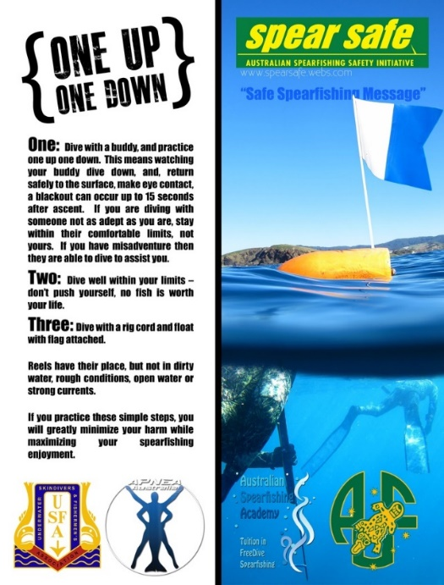
We hope all competitors have an enjoyable and safe competition.

Town of 1770 Location Map
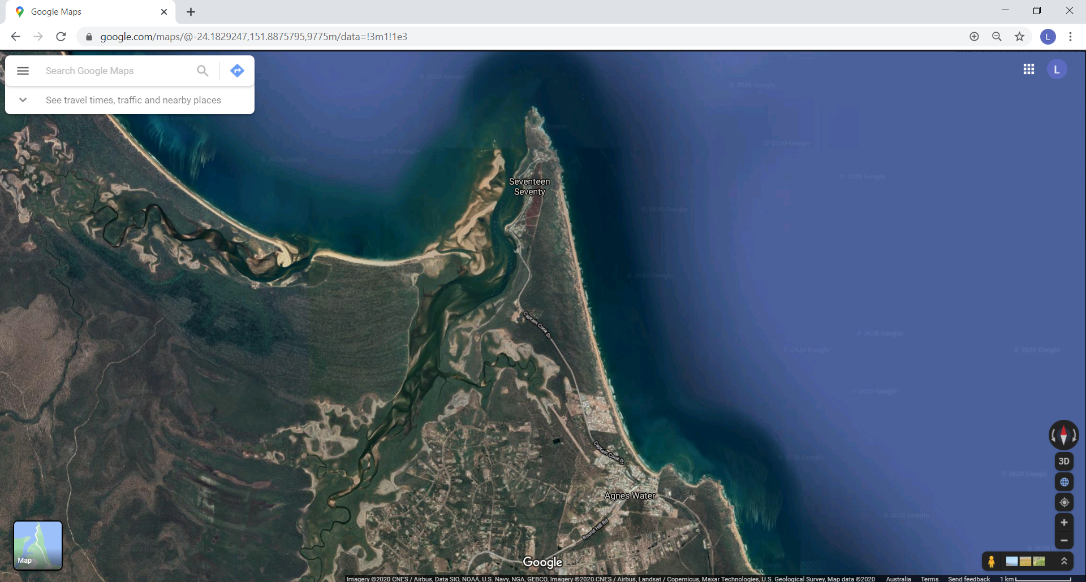

Boat Ramp Location

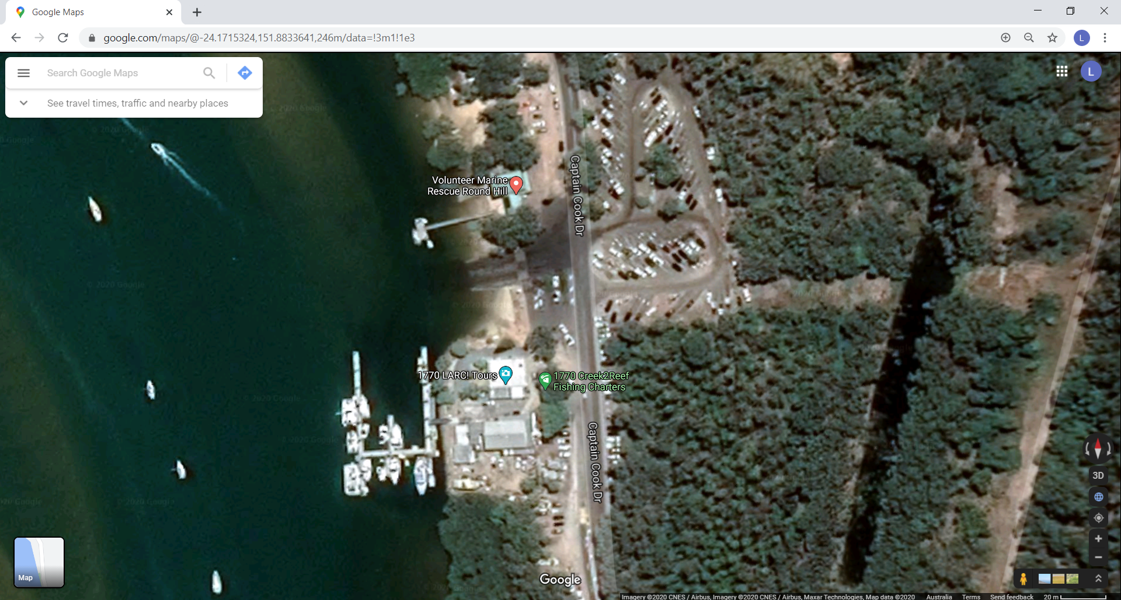

Bunker Group Reefs

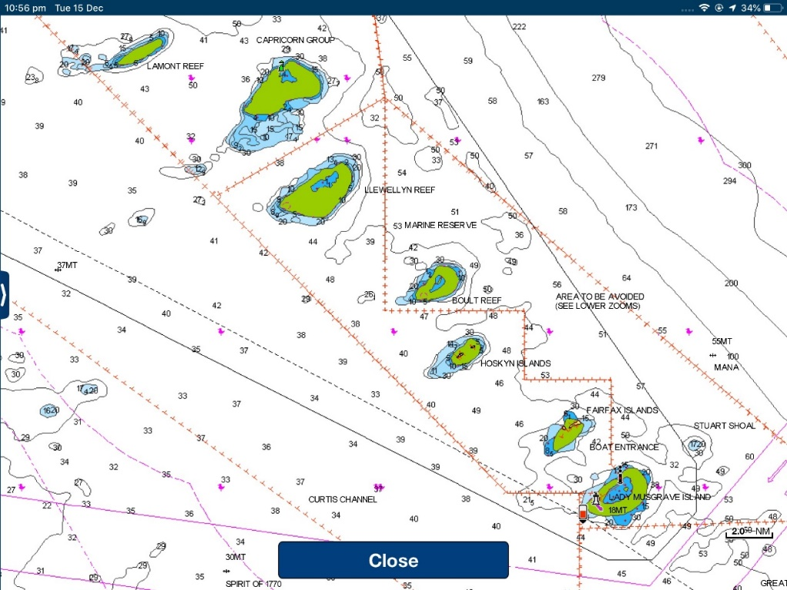

Fitzroy Reef
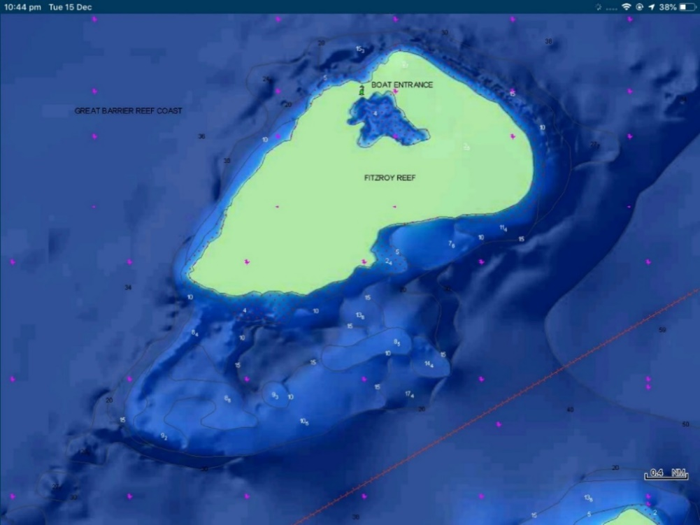

Lamont Reef
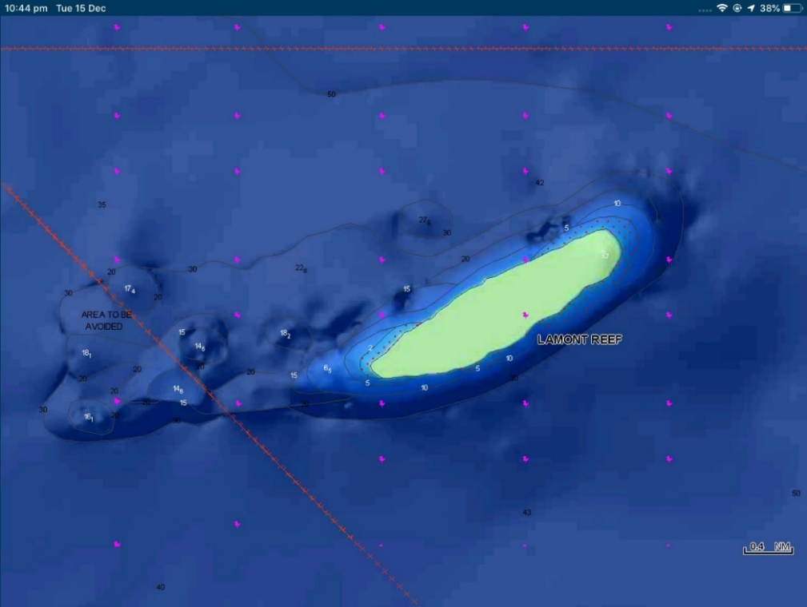

Boult Reef
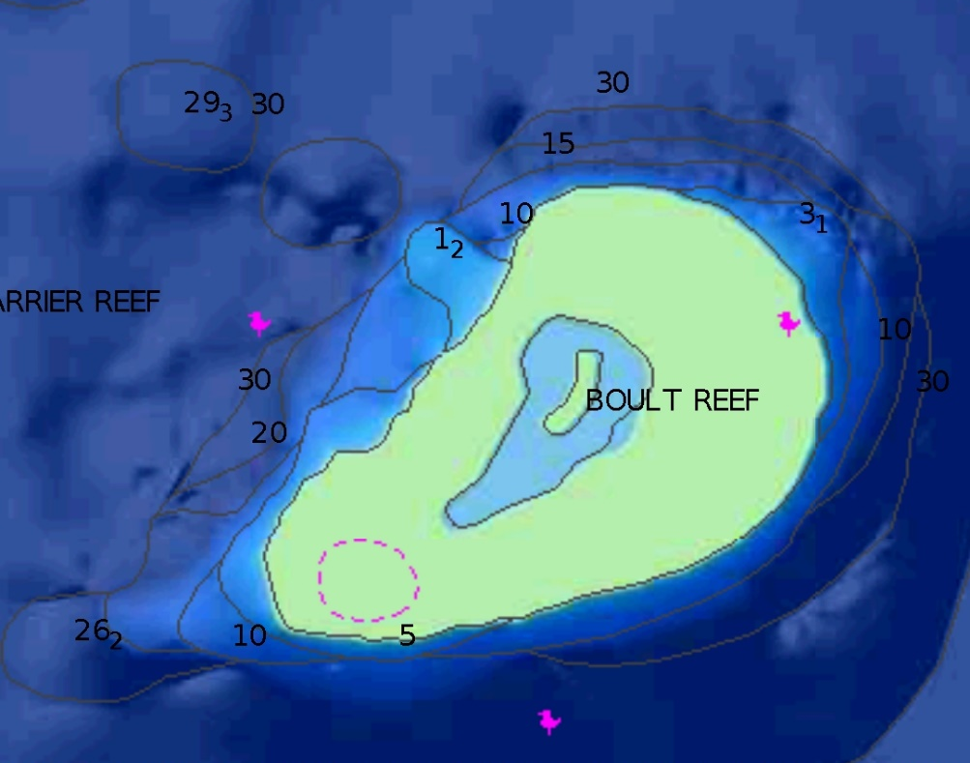

Musgrave Island
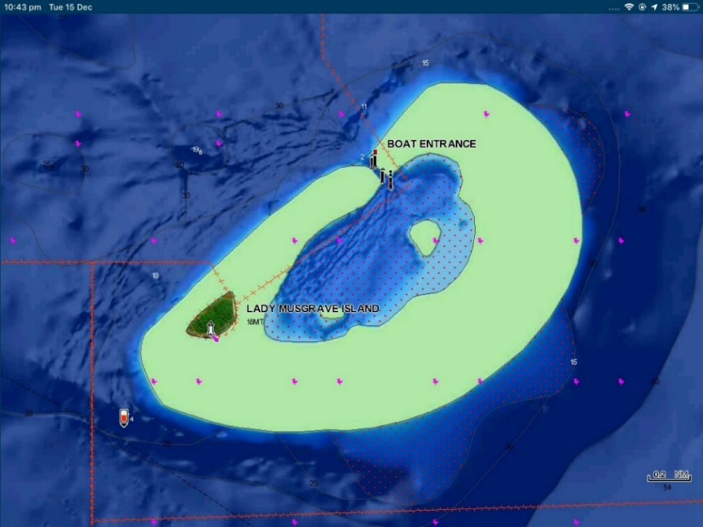

Bustard Head & Jansen Rock
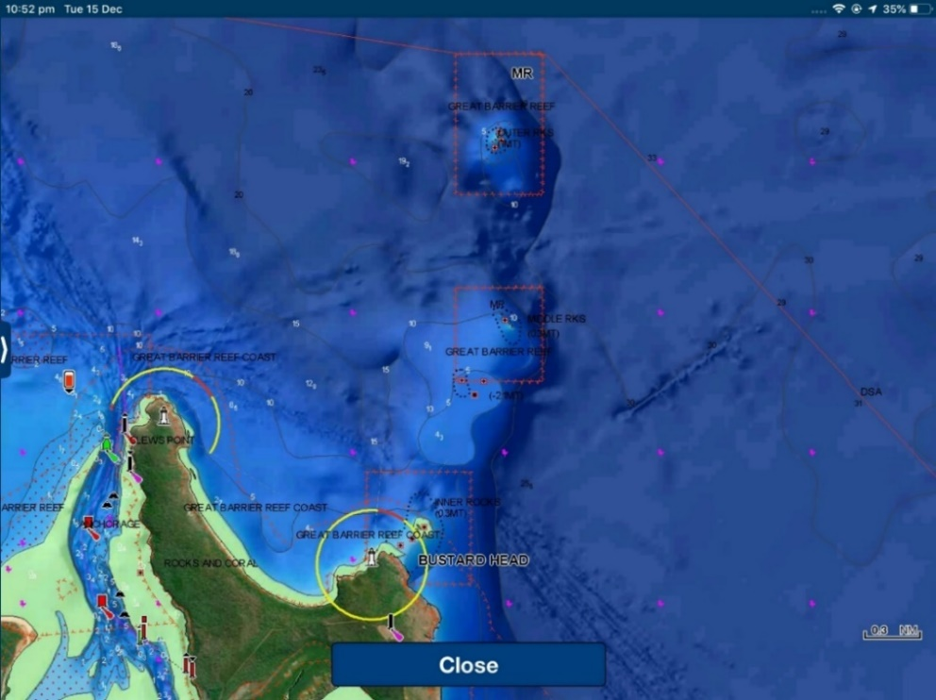

Rock Cod Shoals
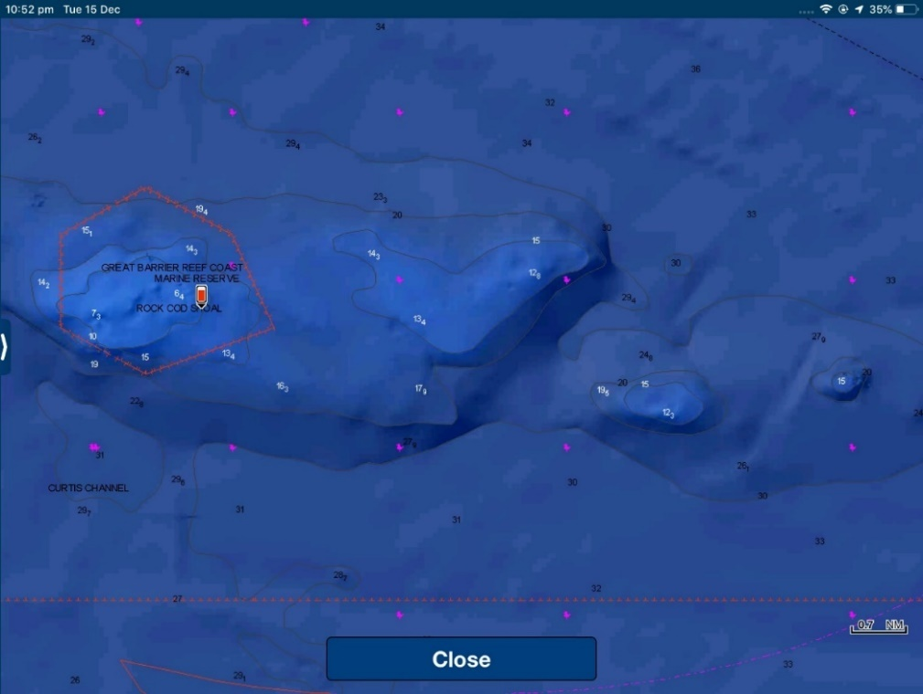

Tide Times
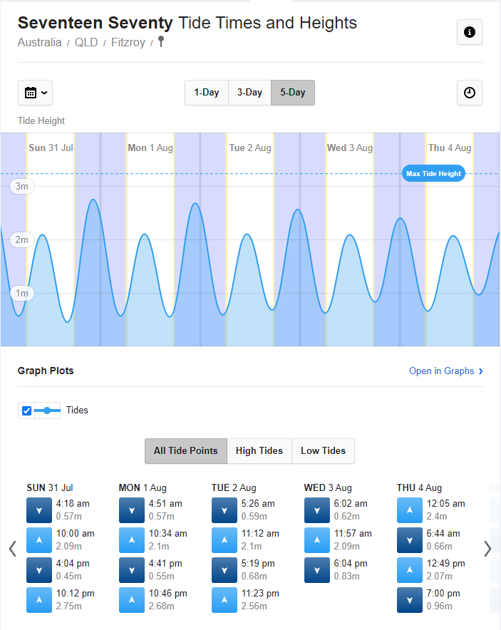

Prevailing Winds
The time of year has been selected for the best chance of the lightest possible winds and most favourable tides.
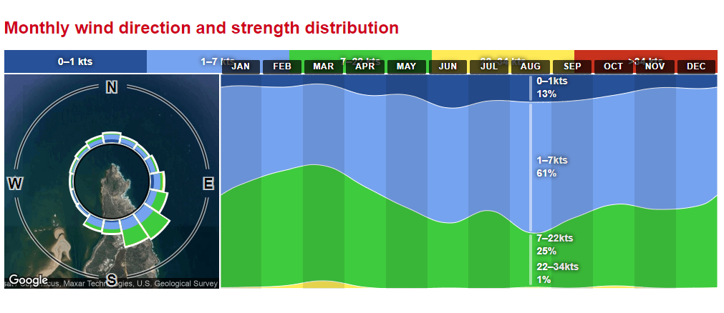

Online Resources
Safety equipment for boats in Queensland:
https://www.msq.qld.gov.au/Safety/Safety-equipment-recreational-ships
Great Barrier Reef Marine Park Map 18 – Capricorn-Bunker Group:
https://elibrary.gbrmpa.gov.au/jspui/retrieve/bc474f3b-75d8-4b34-a610-19ca3da13818/Map18-EditionV-Capricorn-Bunker-Group.pdf
Musgrave Island Lagoon regulations:
https://parks.des.qld.gov.au/__data/assets/pdf_file/0023/166307/lady-musgrave-reg-notice.pdf
BOM 1770 Marine Forecast
http://www.bom.gov.au/qld/forecasts/capricornia-coast.shtml
http://www.bom.gov.au/places/qld/TG78/forecast/
Recreational fishing rules – size and possession limits – tidal waters
https://www.qld.gov.au/recreation/activities/boating-fishing/rec-fishing/rules/limits-tidal
Fish ID
https://www.qld.gov.au/recreation/activities/boating-fishing/rec-fishing/fish-species-guide/fish-species-id
https://www.yumpu.com/en/document/read/15174951/queensland-spearfishing-species/87
http://aufq.auf.com.au/wp-content/uploads/sites/6/2014/04/AUFQ_Records-March-2018.pdf
https://fishesofaustralia.net.au/
No take species
https://www.qld.gov.au/recreation/activities/boating-fishing/rec-fishing/fish-species-guide/no-take-species
https://www.daf.qld.gov.au/__data/assets/pdf_file/0011/64964/ProtectSpecies-RecGuide.pdf

Competition Risk Assessment & Action Plan
Note to competitors: A competitor may enter a safety boat or seek assistance from a safety boat at any time but doing so, for any reason, disqualifies that competitor, and their pair, from that days competition.
Risk | Cause | Avoidance measures | Primary Response | Support Required | Secondary Response
Diver blackout or  drowning, when diver is close to the surface | Diving too deep/long  Insufficient recovery  time before dive  Medical Event  Alcohol/drugs | Agree to limited depth/dive times with your buddy  Limit dive depths and times to within your known ability, having  regard to your physical state  Warn your buddy if you expect a dive to be difficult so they can be ready to provide support  Buddy should monitor every dive and be close enough to assist immediately if diver blacks out  Avoid alcohol/drugs prior to and during event | Recover diver, remove mask, blow gently on face, mouth to mouth if not conscious after short time.  Raise alert by waving gun covered with orange plastic safety sheet / blow whistle to attract safety boat – get someone else to do this if possible | Medic on safety boat, trained for SWB incidents  Equipped with 02 | Diver blackout  protocol
Diver lost underwater | Blackout or entanglement / entrapment | Carry knife, avoid entanglement risks  Do not dive until your buddy has dealt with any speared fish and is ready to watch your dive  Buddy should monitor every dive and be ready to assist if you do not surface when expected  Surface diver should monitor float line for direction of diver | Follow float line and search immediately for diver. If not found immediately, enlist surrounding divers.  Mark location if possible: consider  firing gun into bottom as marker, take note of where you are  Maintain a conservative and safe  diving pattern to ensure you also do not blackout  Recover diver only if safe to do so. Remove weight belt if necessary and bring diver to surface lifting under chin to hold their mouth shut.  Proceed immediately with mouth to mouth  Raise alert by waving gun covered with orange plastic safety sheet / blow whistle to attract safety boat | Safety boat must have a SCUBA diver and SCUBA gear for diver/body recovery | Medic to assess diver for appropriate response
Diver DCS | Diving too / deep too long / not enough recovery time before dive | Avoidance measures Buddy control, self control  Do not do weight assisted  descents | Raise alert by waving gun covered with orange plastic safety sheet / blow whistle to attract safety boat – get someone else to do this if possible | Medic on safety boat, supply 02 | Request rescue helicopter to evacuate diver to nearest decompression  chamber.
Lung or Trachea  Squeeze | Straining/flexing arms, body, or neck at depth damages lung or  trachea. Diver will cough up blood | Limit dives to depths you are comfortable at, and avoid twisting  body, extending chin | Raise alert by waving gun covered with orange plastic safety sheet / blow whistle  Alert safety boat, stop diving | Medic on safety boat to evaluate | Consult doctor and  specialist as ordered

Risk | Cause | Avoidance measures | Primary Response | Support Required | Secondary Response
Diver run over by boat including safety boat | Diver not visible Boat driver not aware or not paying attention  Diving in high traffic  area  Sun strike | Boat must not manoeuvre around a pair of divers unless both are visible on the surface  5 knot rule  Communicate with  surface diver before coming within 50 metres of any divers  Safety boat drivers to  be vigilant | Apply pressure to wound, keep head out of water  Raise alert by waving gun covered with orange plastic safety sheet / blow whistle to attract safety boat  Recover to boat | Medic on safety boat equipped with first aid kit | Transport to hospital if required
Boat strike (unknown  boat) | Lack of visibility  Boat driver not obeying  5 knot rule  Sun strike  Boat driver unaware | All floats/plats must carry flags, min 15x20 cm  Safety boat with dive flag to patrol other boats and warn of  diver presence Notify boating public by VHF/media communications  Divers to avoid diving in high boat traffic areas, or at least remain aware when crossing such areas  Raise gun/wave to alert oncoming boats | Try to get boat to stop and take you to safety boat.  Raise alert by waving gun covered with orange plastic safety sheet / blow whistle to attract safety boat.  Apply pressure to wound, keep head out of water. | Medic on safety boat equipped with first aid kit | Transport to hospital if required
Diver puncture wound | Spear wound  Cuts from knives/fish  Falls/head knock  General  Sickness/minor  injury  Fish spines | Self-management  Never point a loaded gun at another person Unload gun before existing water  Care when cutting fish  Tip protectors on spearguns when out of water  Never hang extra spears or guns from float pointing downwards, or loaded | Raise alert by waving gun covered with orange plastic safety sheet / blow whistle to attract safety boat.  Apply pressure to wound, keep head out of water. | Medic on safety boat equipped with fist aid kit | Transport to hospital if required
Diver lost in current | Unable to swim against current in high current areas | Monitor strength of current with return swim in mind | Raise alert by waving gun covered with orange plastic safety sheet / blow whistle to attract safety boat.  Swim across current to get out of it  Conserve energy, stay together, use float/plat for support.  Fire gun into reef or tie rig line onto reef and hang onto float / plat.  Safety boat to search | If not found in short  time. Contact Coastguard for broader search | Transport to hospital if required

Risk | Cause | Avoidance measures | Primary Response | Support Required | Secondary Response
Shark bite | Using fish for burley | Do not burley  Move away from others using burley when sharks arrive  Be wary when retrieving fish with  known shark presence.  Safety diver to hold guard.  Get fish out of the water and into a float / plat as soon as possible. | Raise alert by waving gun covered with orange plastic safety sheet / blow whistle to attract safety boat.  Apply pressure to wound, keep head out of water. | Medic on safety boat equipped with first aid kit | Transport to hospital if required
General sickness/nonurgent  injury  (not  in  competition) | Any | - | Contact local doctor | Transport to doctor | Transport to hospital if required
Dehydration | Forgot to bring a drink with you | Attach water bottle to float | Summon safety boat with raised gun when you see it. | There will be water on the safety boat | If severe dehydration, remain on safety boat  until Medic says OK to dive
Hunger | Forgot to bring food forthe day | Bring food in your plat or have food on your boat and return during the day to eat it | Summon safety boat with raised gun when you see it.  Beg for food. | Safety boat driver’s  lunch | Remember to bring food next time
Exhaustion | Caught in currents or rough water  Not enough food/drink | Assess currents and rough water as you enter them and do not swim too far | Rest on shore if safe to do so in sea conditions  Have food/drink  Summon safety boat with raised gun when you see it.  Conserve energy and hold on to float, stay with buddy | Rest on safety boat | Bring adequate food and water; perform within your limits.
Medical event due to  existing health issues | Various | Self-assessment of risks Disclose pre-existing risks to organisers in  registration form  Have own medication on hand or on safety boat if required | Get to safety boat for Medic support  Raise alert by waving gun covered with orange plastic safety sheet / blow whistle to attract safety boat. | Medic on safety boat to assess | Further medical  assistance
Boat  breakdown/sinking | Various | Maintenance  Care when anchoring | Request a tow back | Have VHF onboard  Boats travel in groups to competition area  Tail end Charlie | Re-allocate divers to other boats

Medical and Emergency Contact List
 | Is someone seriously injured or in need of urgent medical help?  Do you want Police, Fire or Ambulance?  Call Triple Zero (000)  Important – if there is no mobile coverage on any network, you will not be able to reach the Emergency Call Service via a mobile telephone.  In a marine based emergency use VHF Channel 16
​​​​​​​​​
FIRST CONTACT:
Police | Phone: (07) 4899 4000  Address: 10 Springs Road Agnes Water QLD 4677  Opening hours:  In an emergency call 000  Call 131 444 to contact Police other than in an emergency.
  Monday - Friday | 9:00am–3:00 pm
  Weekends | Closed
Volunteer Marine  Rescue Round Hill | Phone: (07) 4974 9383  Emergency After Hours: 0427 747 477  Address: 539 Captain Cook Drive Seventeen Seventy QLD 4677  Opening hours:  Radios are manned seven days a week from 0630hrs to 1800hrs daily, with an emergency night watch on VHF channel 16 from 1800hrs to 0630hrs.  Radio Frequencies:  VHF: 16, 81, 82  27Mhz: 88, 91
Australian Volunteer Coast Guard | QF11 Yepoon  Phone: (07) 4933 6600 | 0419 794 812  Address: 21 Anchor Drive Yepoon Queensland 4703  Opening hours / Radio monitoring hours:  Radio Frequencies:  VHF: 16, 21, 22, 67, 82  CALL SIGN: VMR411  Call Sign Name: Coast Guard Yeppoon
  Monday - Friday | 9:00 am – 3:00 pm
  Weekends | 6:00 am – 6:00 pm
VHF Channel | Use Channel 16 in the event of a marine based emergency

Medical and Emergency Contact List cont…
SECOND CONTACT:
VHF local channel: | All boats to monitor Channel 16;  For non-essential competition communications switch to: Channel 73
VHF nowcasting /forecast: | Most coastal radio stations provide regular local weather forecasts on VHF radio, with instructions and broadcast times announced regularly on Channel 16.
Medical: | Discovery Coast Dental and Medical Centre  Phone: (07) 4974 7475  Address: 3 Captain Cook Dr, Agnes Water QLD 4677  Opening hours:
  Monday - Friday | 9:00 am – 5:00 pm
  Weekends | Closed
Medical: | Shore Care Family Practice  Phone: (07) 4902 2018  Address: 2 Rafting Ground Rd, Agnes Water QLD 4677  Opening hours:
  Monday – Thurs | 8:00 am – 4:30 pm
  Friday | 6:30 am – 2:00 pm
  Weekends | Closed
After hours care: | Shore Care Family Practice: 0499 059 388
Hospital | Bundaberg Hospital | 24 Hour Emergency Department  Phone: (07) 4150 2222  Address: Bourbong Street Bundaberg QLD 4670
Fire Emergency: | CALL 000
Nearest Decompression chamber: | Royal Brisbane and Women's Hospital| 24 Hour Emergency Department  Phone: (07) 3646 0241  Address: Butterfield St, Herston QLD 4029  https://metronorth.health.qld.gov.au/rbwh/healthcare-services/hyperbaric-medicine
Pharmacy: | Agnes Water Pharmacy  Phone: (07) 4974 9700  Address: 2 Heights Entrance Agnes Central Shopping Centre,  Agnes Water QLD 4677  Opening hours:
  Monday - Friday | 8:30am – 5:30pm
  Saturday | 8:30am – 12:30pm
  Sunday | Closed
Chopper pad / airstrip: | Agnes Water Airstrip  Les Woodall | 0428 661 434  217 Captain Cook Dr, Agnes Water QLD 4677

